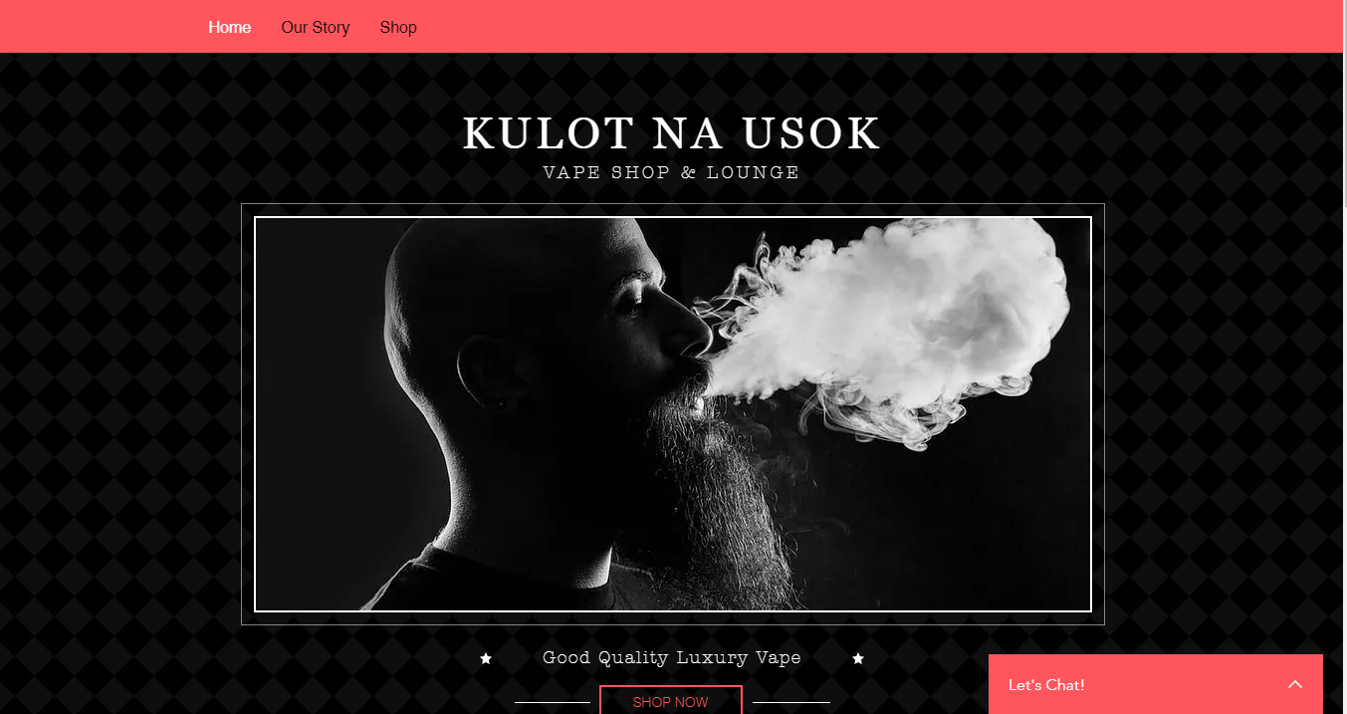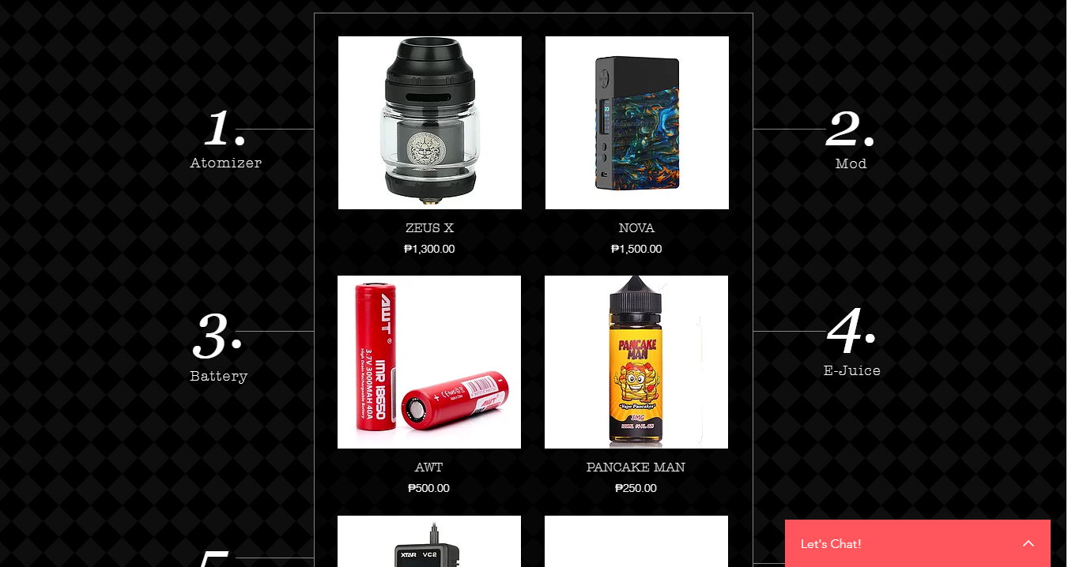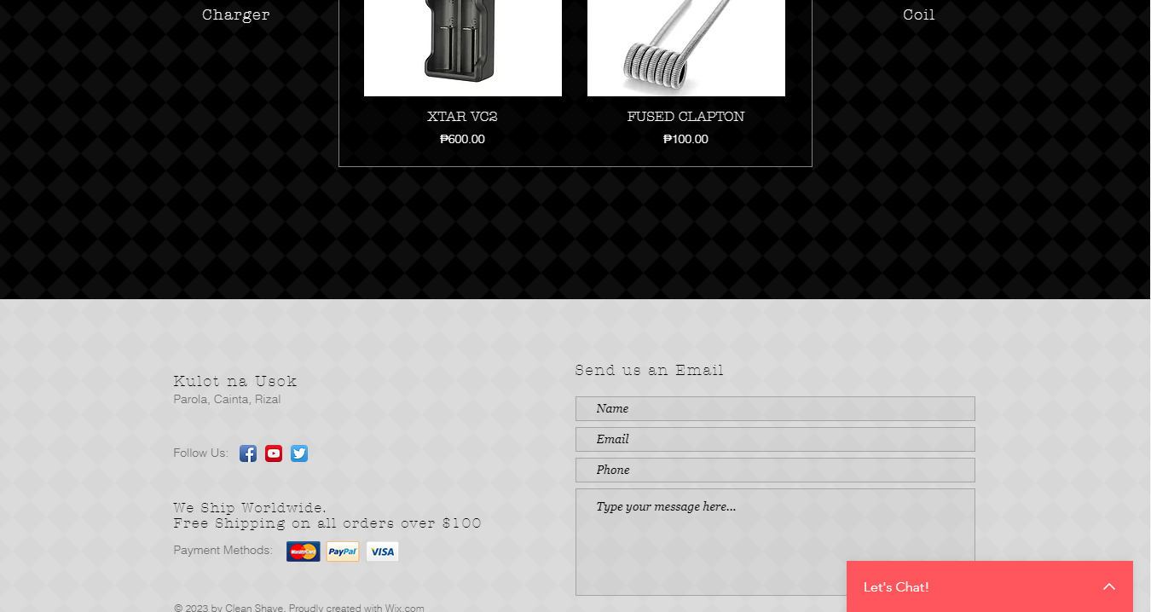

This is the first page of my website where the user can briefly see the information and the products that are available on the website.

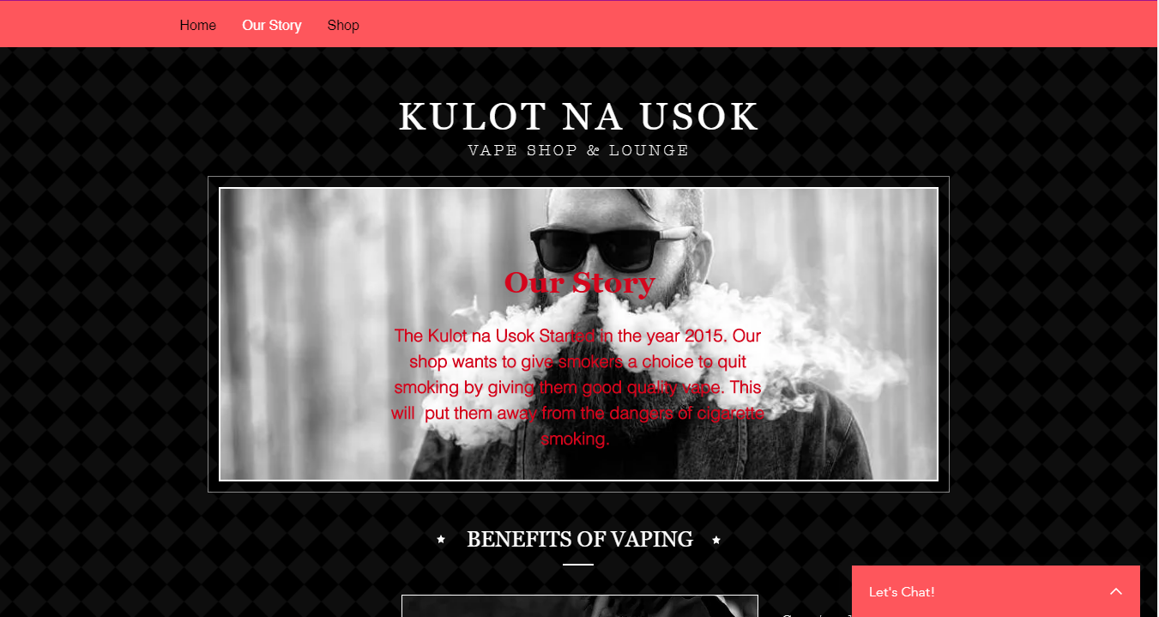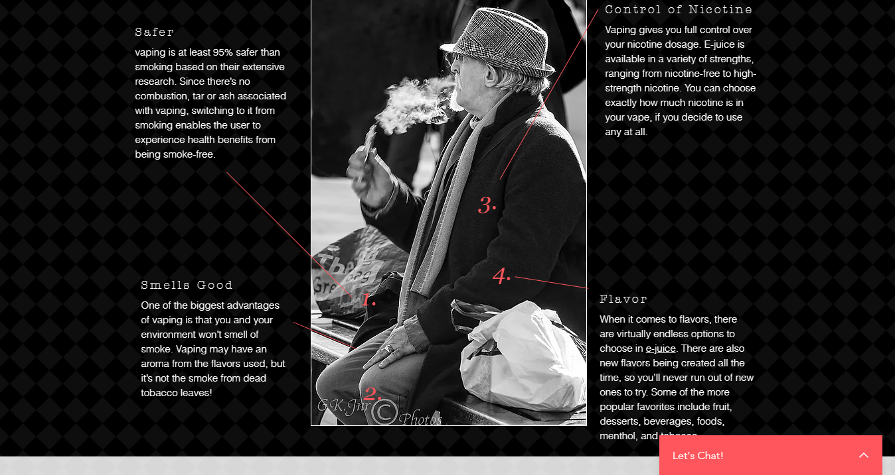

The second page is all about the shops history and all the information about it. Also we put the benefits of vaping so our customers know what vaping is all about.

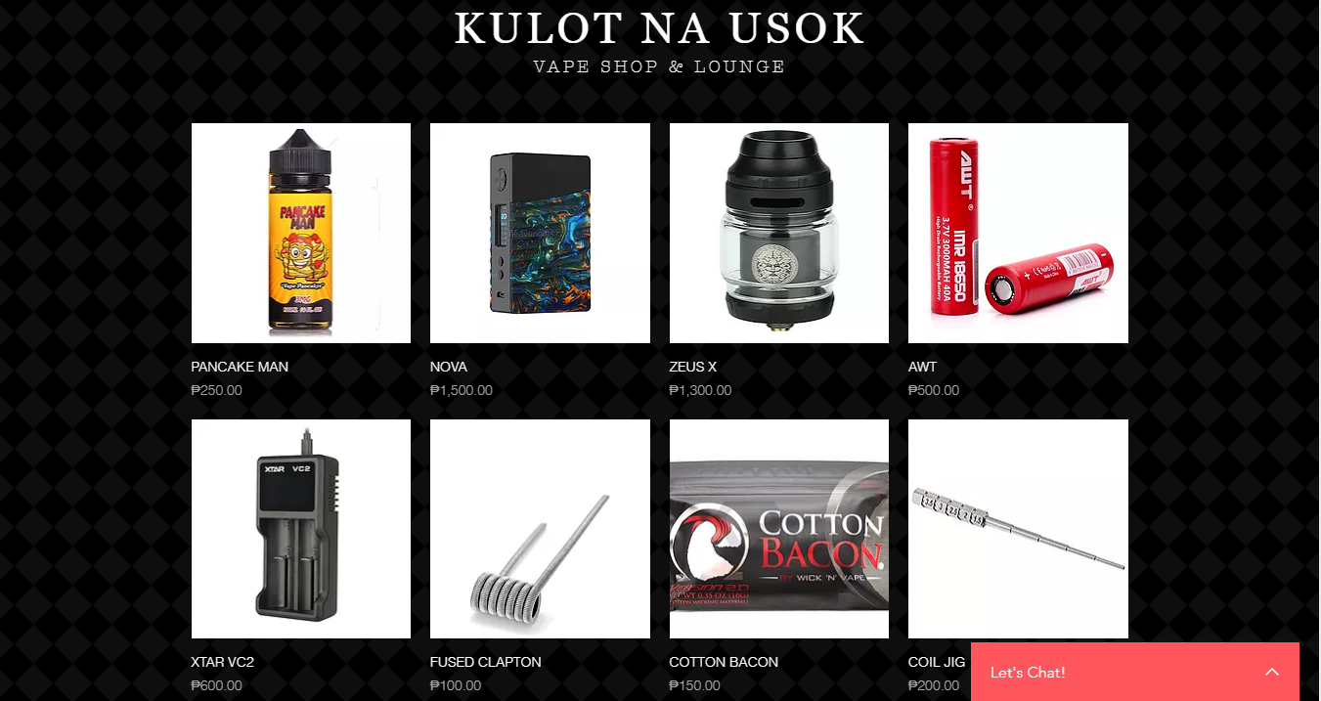

This is the last page of the site where users can see all the products available in the website and the description of each product available.